**Catapult Games**

**Overview:**

* The main point of the game is to get the player as far a possible while racking up the highest score
* This is done by launching the player, and having the playing collide with objects mid-air, or objects that are on the floor
* The player will then earn a score and money or currency of some sort
* The player will then use said currency to upgrade the devices used to launch the player, (ramps, characters hitting you, or catapults) upgrade objects you can collide into and upgrade weapons or characters or items give you the ability to either hit the player mid-air or to give the player a second wind of some sort.

**Game Loop:**

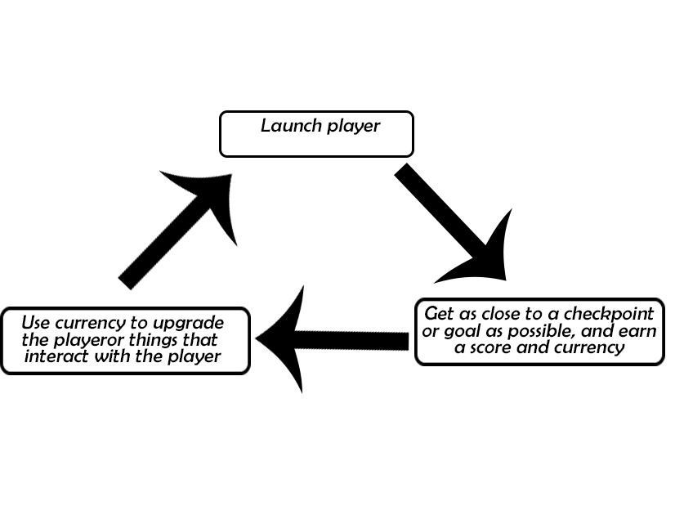

**Core Strengths:**

* One of the main strengths that these types of games have, is the amount of replayability there is. Due to a single “run” or launch of the player character not being too long, this allows the player to enjoy the cycle (see diagram above) without feeling it is too time consuming.
* Another strength is the fact that the games cycle is a quick one, it allows the game to be played in small chunks whenever and where the player feels, this is similar to idle games and snack games.
* There is a sense of progression as you are always moving towards the goal or checkpoint with every launch as the player is given the option to make upgrade before the next launch.

**Art styles:**

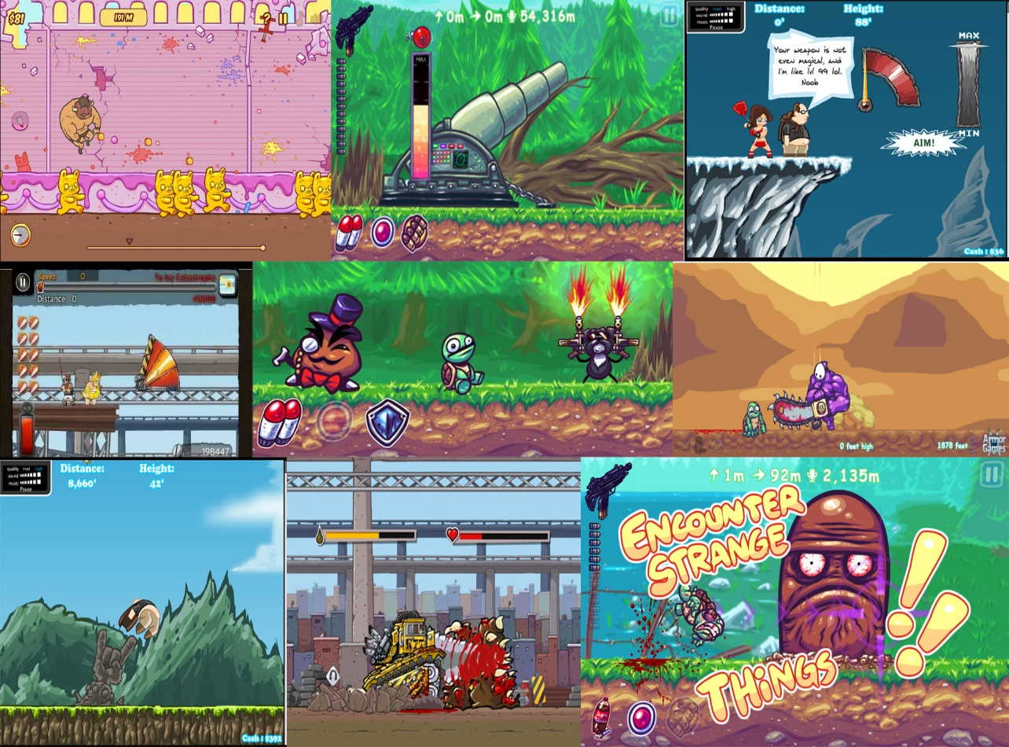

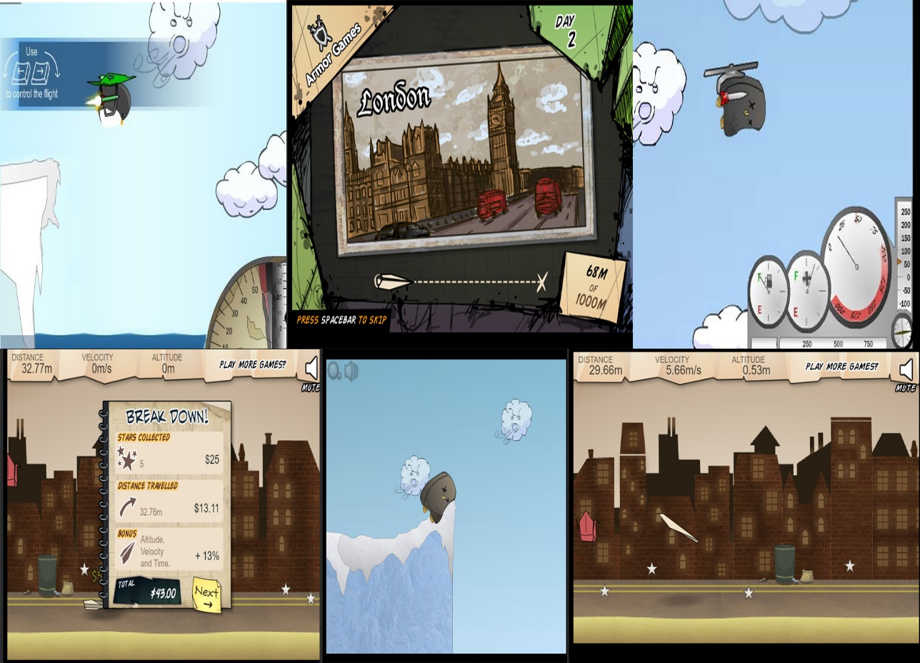

* 2d art style
* Strong outline on the player
* Simplistic background
* Extremely cartoon-ey art style
* UI is either there when needed and is consistent throughout the game
* Colours to compliment the mood of the game (loud bright colours for the violent catapult games, and cooler more calmed colours for the games where violence is not a theme)

**Demographic:**

This is subject to change depending on the theme the game has taken for example:

* A theme orientated around violence e.g. War will have a demographic of 18-24 males
* A theme orientated around time taking e.g. a garden theme would have a demographic of 20 – 35 females

However, based on Q4 of the UK games industry in 2016 (Luke, 2016) the largest demographic is 15-24-year-old males so if it could be argued that this is the optimal demographic to try and hit as it is the largest.

**Possible Issues:**

* Due to website that host free games (miniclip, kongregate, armorgames etc.) it would be hard to either make profit through monetization or making the game have a onetime fee, as there would be something similar on one of these sites that the player could access instead.
* Would be hard to come up with a theme that made sense and that stood out, as many similar games use flightless birds or use excessive violence.
* There doesn’t seem to be a need for catapult games, because of this if an attempt were to be made it would have to do something that no games of the genre had done before.

**Unique elements:**

* Making the game 2.5d rather than 3d will let certain aspects of the game shine out and could be used in conjunction with visual effects to create special moments throughout the game
* Allowing the user to choose their own music